# Escape Room Visuals

To find out what an escape room looks like both in person and digital I decided to do research on escape room visuals. I looked not only at online rooms but also at all the other options like VR and in person to maybe be able to use some of the gained knowledge to create something new. The research can be read below

## Research

**What does an escape room look like?**

Escape Rooms often focus on a certain theme for the design of the rooms, this is applicable to not only real life escape rooms but also virtual rooms, online rooms and board games. Themes can be realistic but also futuristic or complete fantasy. Some examples of themes can be: Video Games, Nuclear Disaster, Treasure hunt, Future, Crashed planes, Lost on an island or even just a studie/home from a person. These themes will be found all across the escape room not only in the design but also in the puzzles, making the objects inside the room fit into the environment and usable for solutions. Having this theme throughout the entire experience makes it feel more realistic and oftentimes more fun.

Because of the theme the visuals of an escape room van vary a lot from extreme futuristisch with bright LED lights to a dark cabin in the woods or the studie from a historian. Everything is possible. 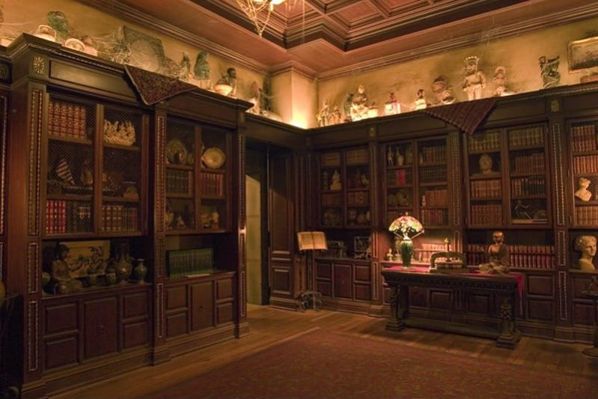

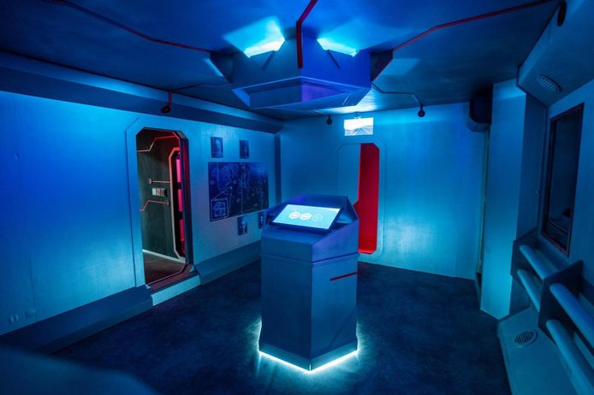

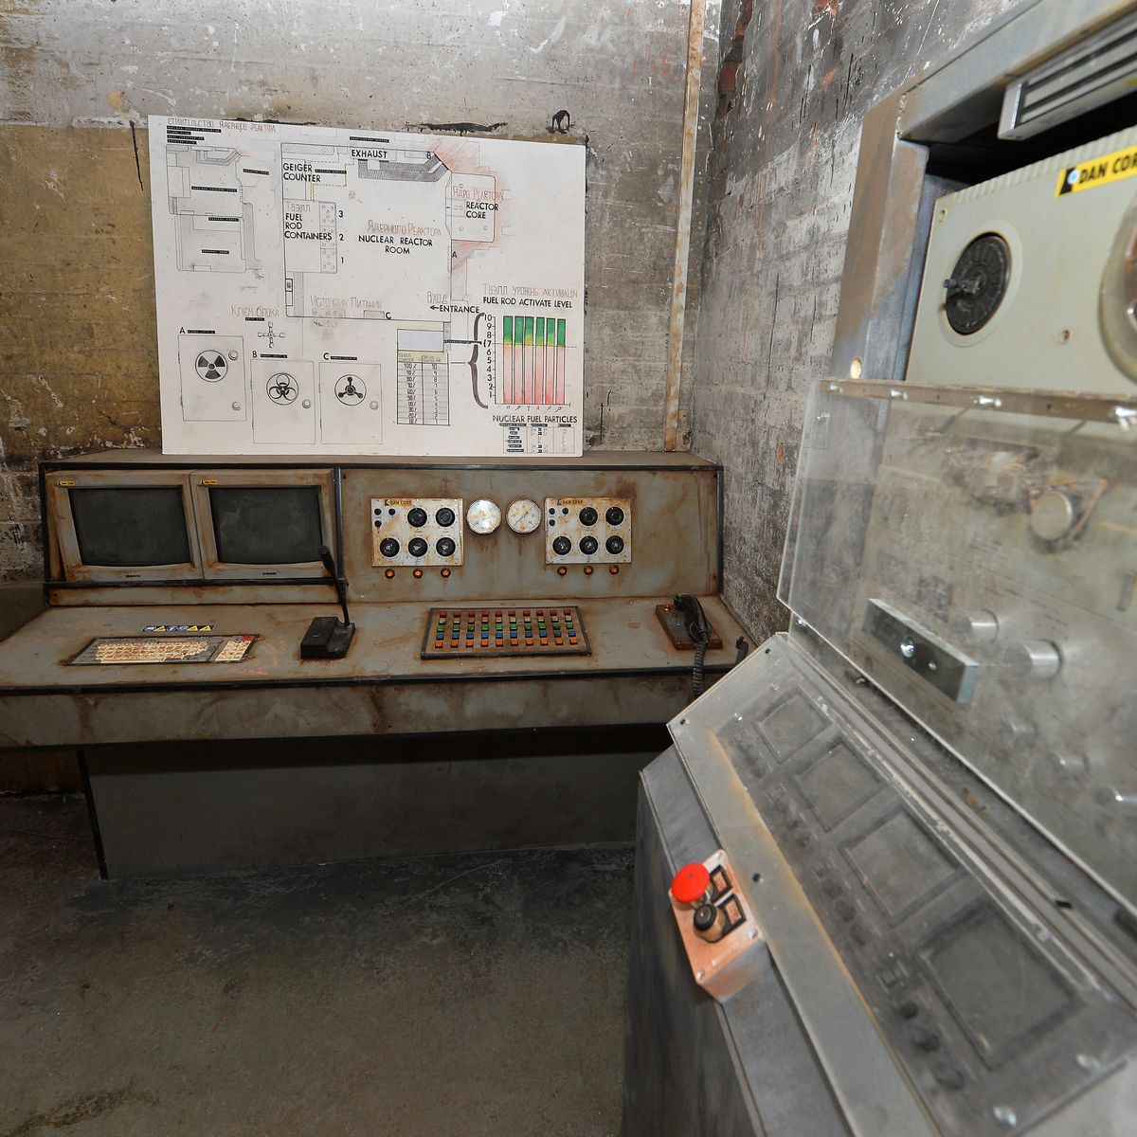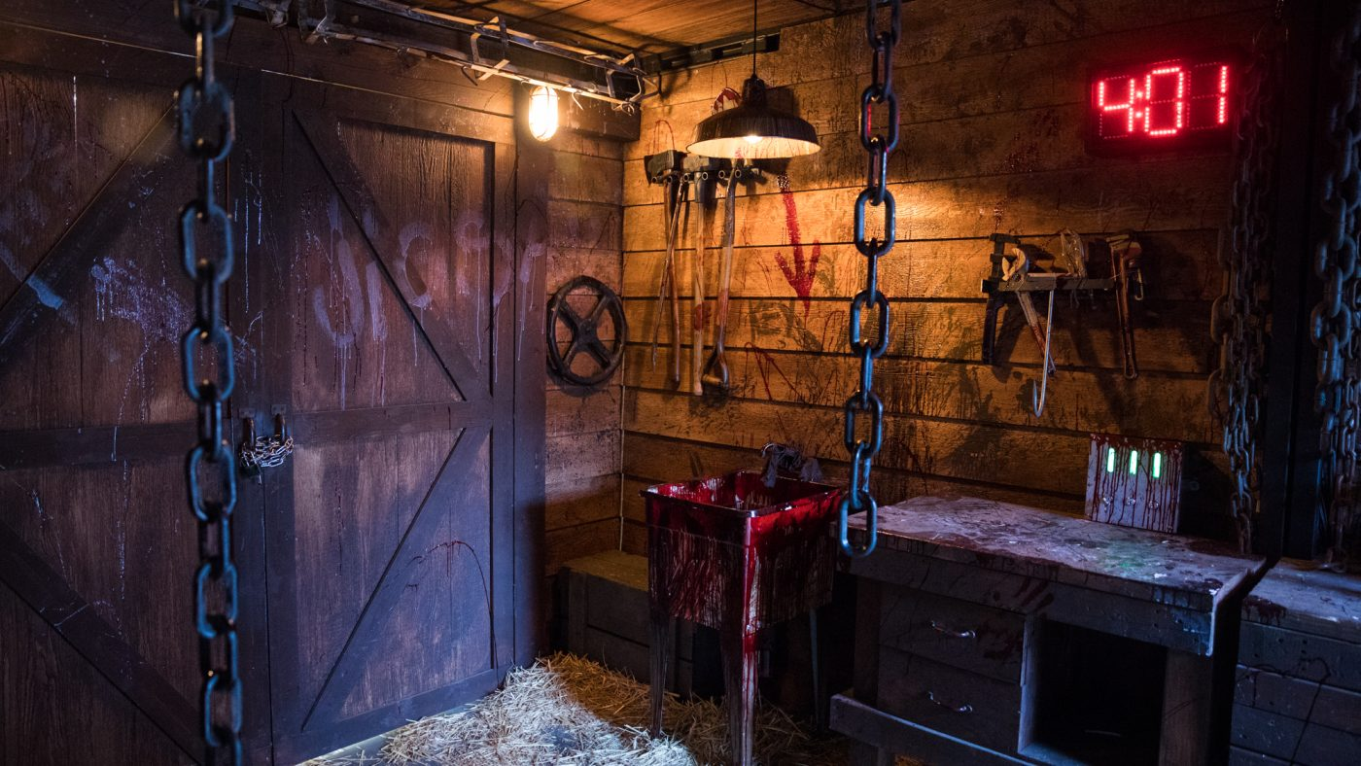

In Virtual Reality escape rooms the possibilities are even more endless then in real life, you can do things that real life physics don’t allow and make people really feel like they are in a different dimension or trapped on the moon. 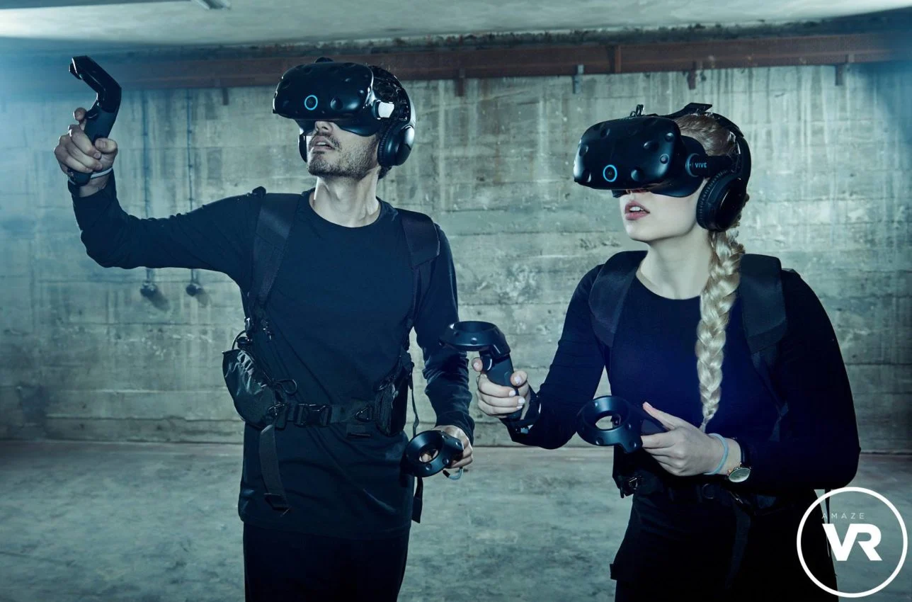

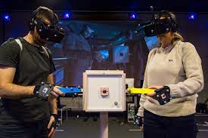

Another version is the virtual escape room or remote escape room in which players online can control a real life person trapped in an environment, this person is sometimes called the player character since they can be compared to a character someone can control in video games. The biggest difference between these virtual rooms and real life rooms is that the players aren’t in the room themselves. Because the person in the room is an actor they can make the situation feel pretty realistic or pretend doors are locked and get unlocked with a correct action, theme wise these rooms can be compared to the in person escape rooms. 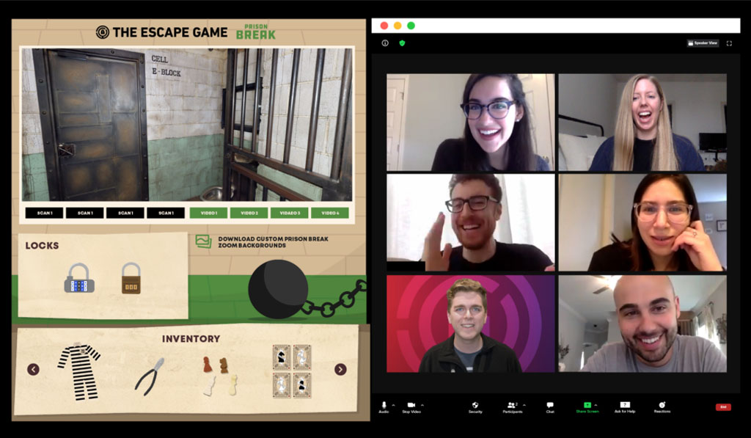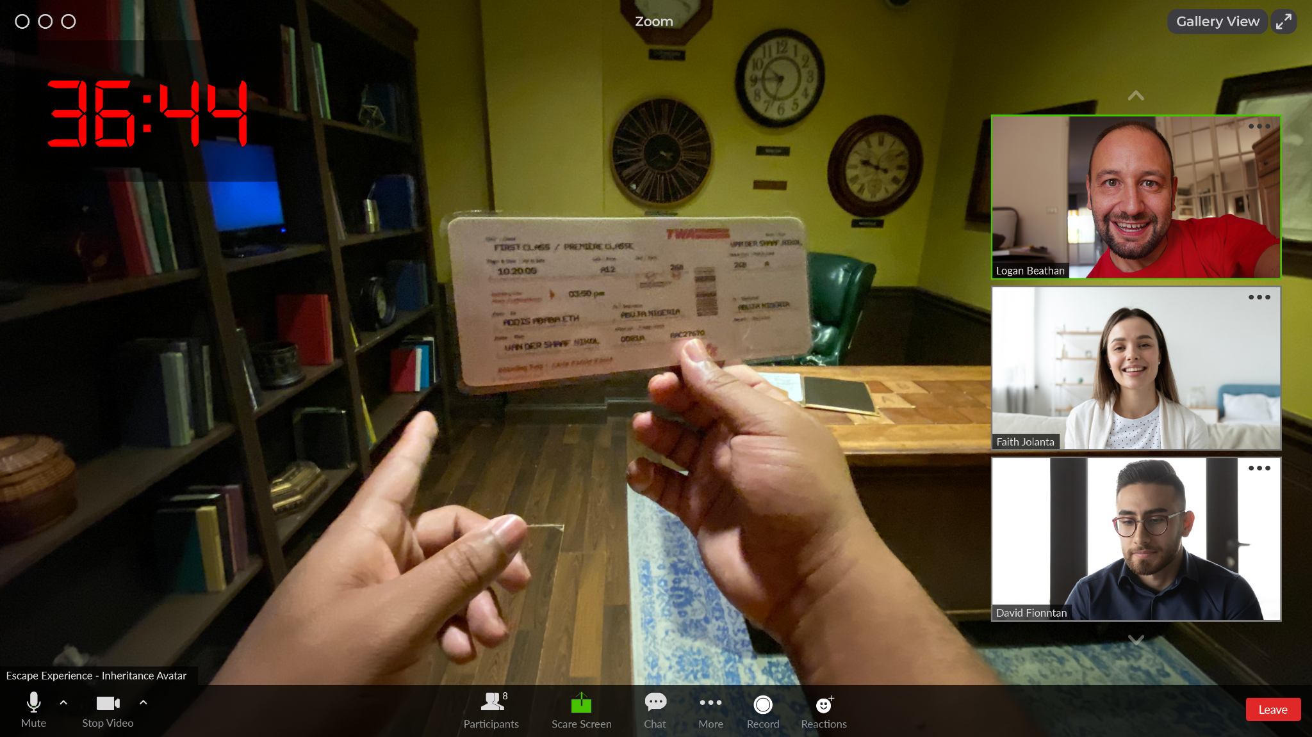

With the rising popularity of escape rooms also came the escape room board games or the escape room in a box. This is a kind of an escape room someone can play at home or other place. The at home escape room often doesn’t require anybody to set it up and thus learn the solution, it’s ready to go as soon as you open the box. Another type is more aimed towards schools or activity groups, someone has to set it up in a place and sometimes add some hints or small things. Both of these types of escape rooms make use of themes but they often aren’t as immersive as the other types of escape rooms because they lack the ‘room’. 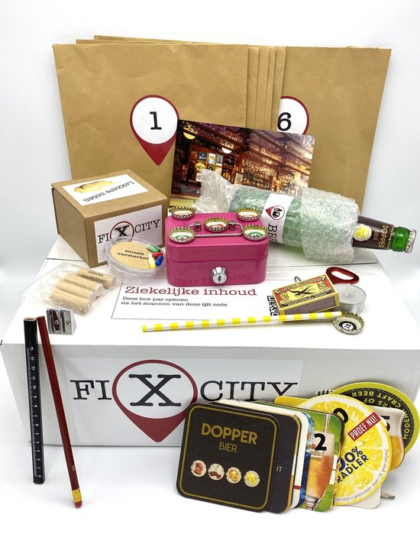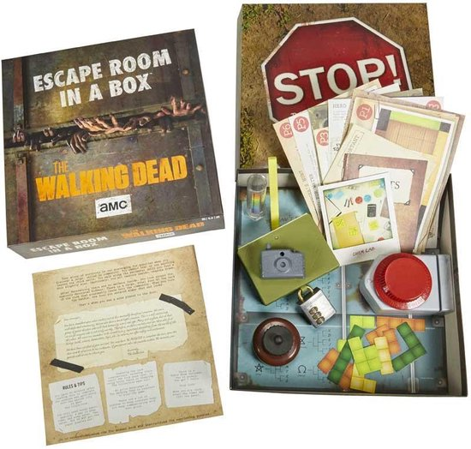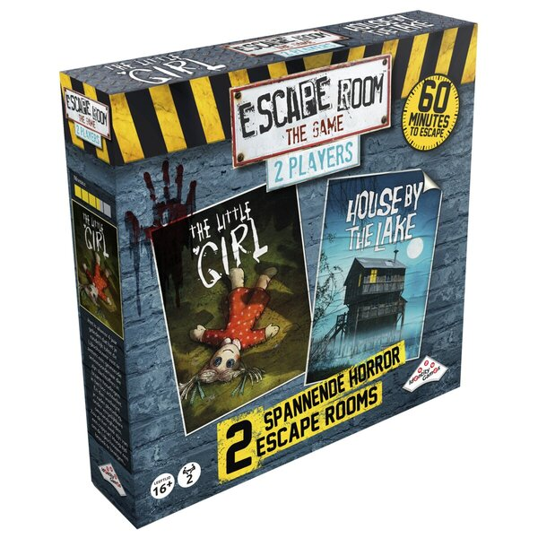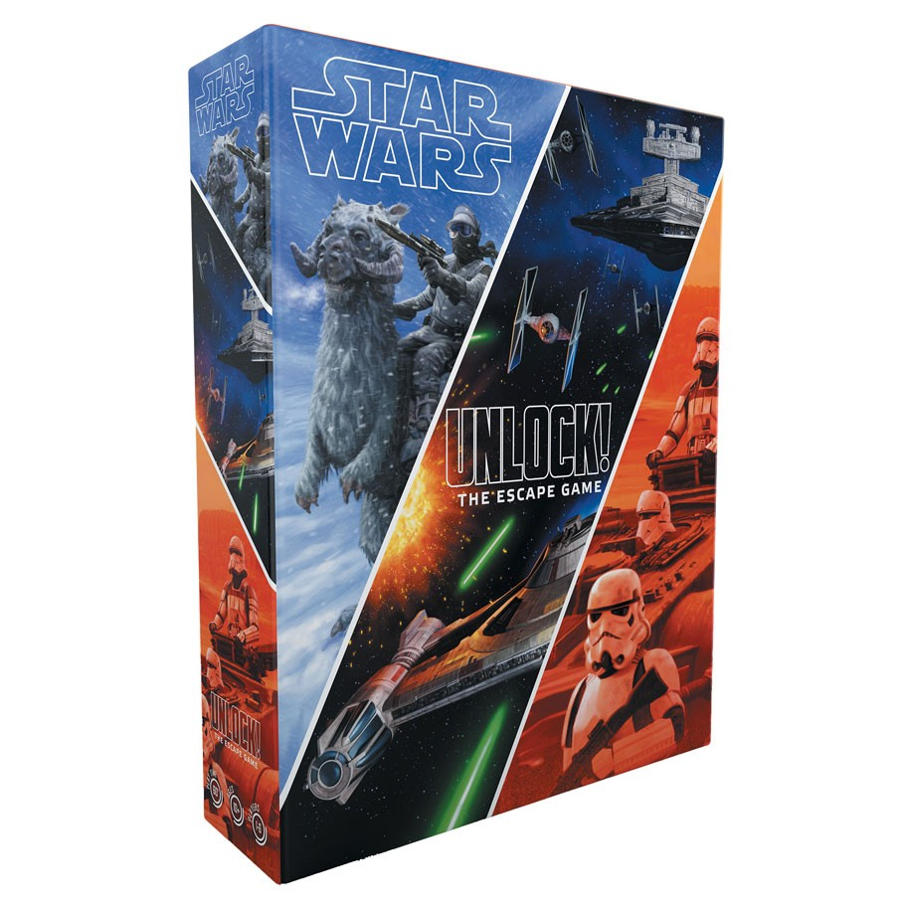

Online escape rooms come in many shapes and forms but they all still have a theme. One version is the mobile game where people just have to click on areas that are often in a more old fashioned style where people have to escape a building with a lot of different floors or rooms. But there are also more 3D style games to play on a computer like escape simulator.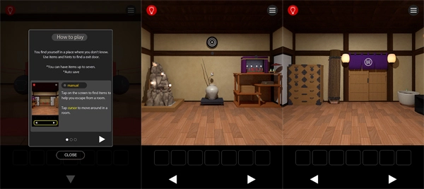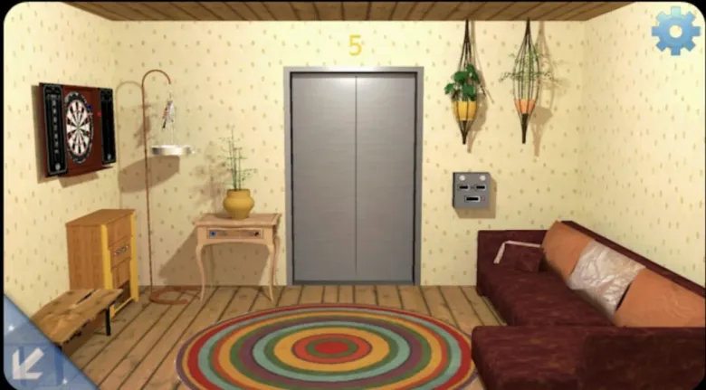

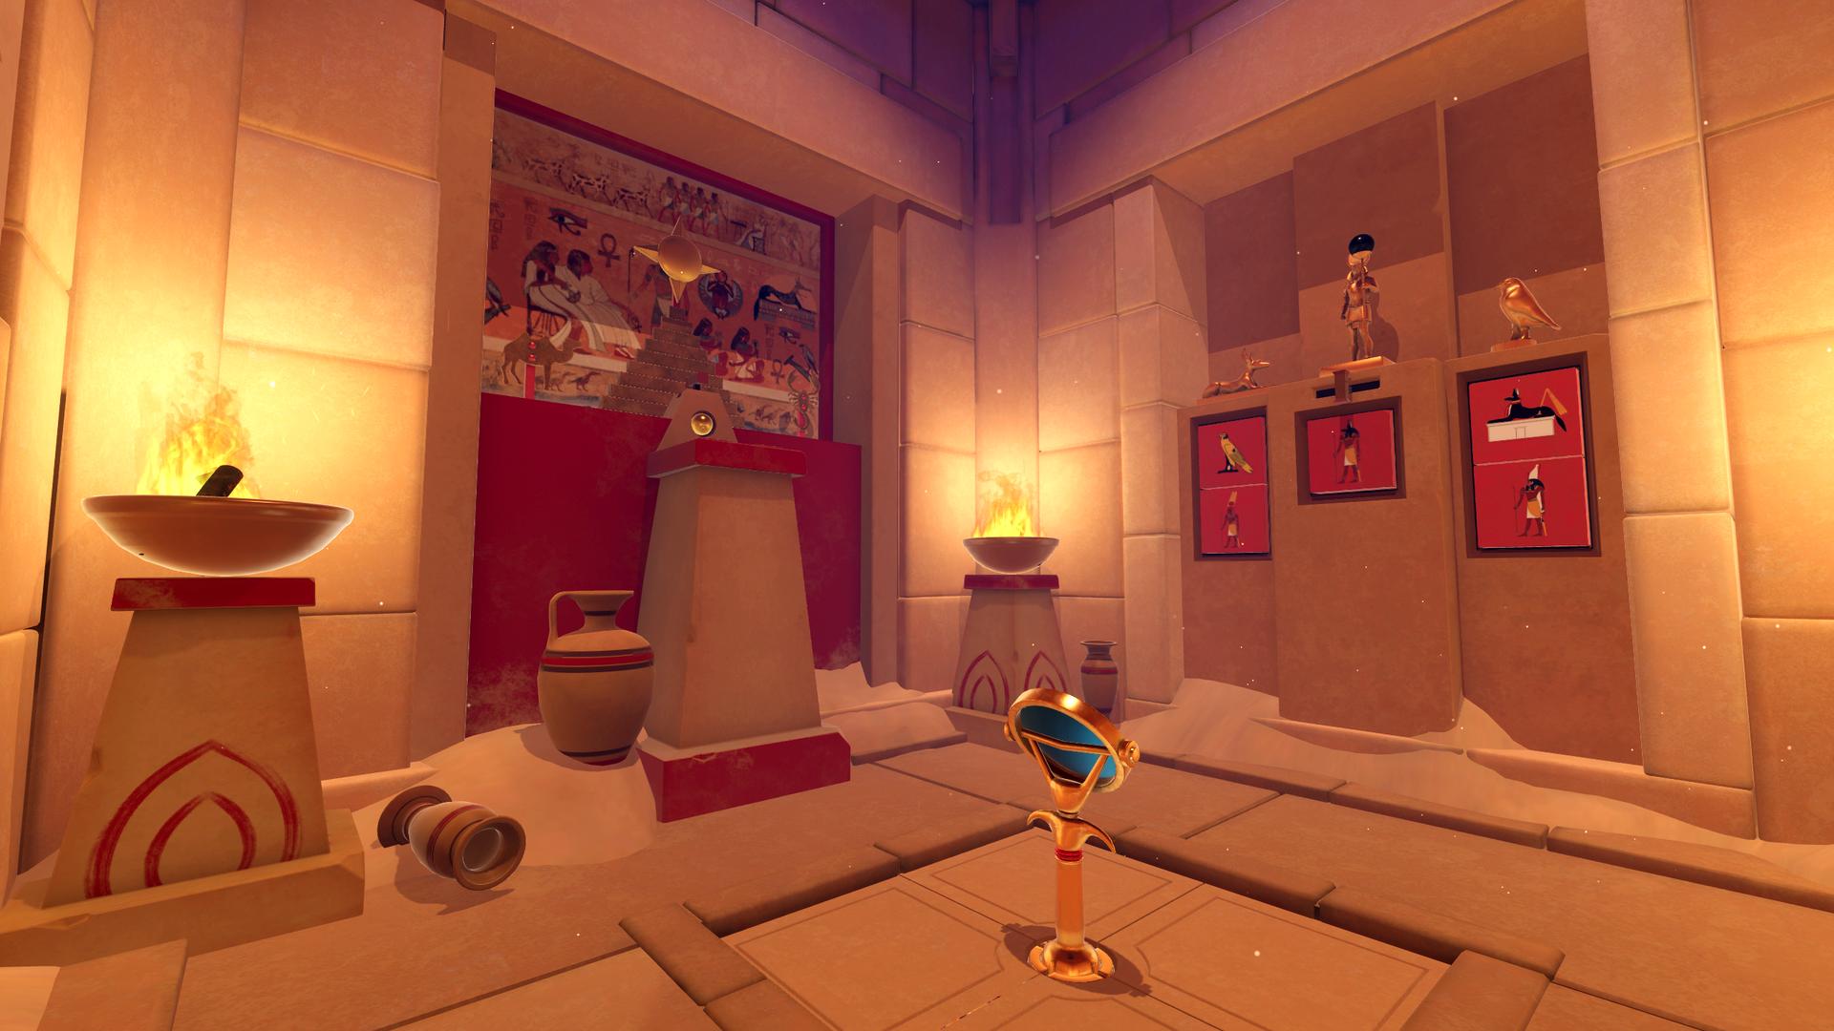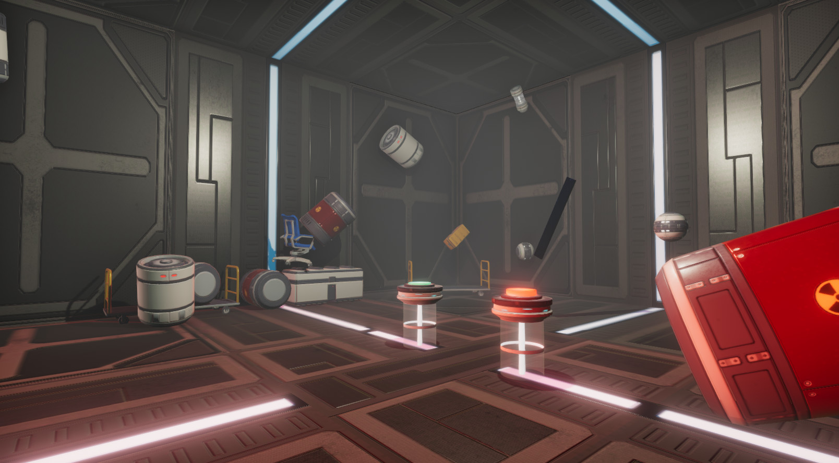

A Mobile escape room is an escape room that is often built in a shipping container, bus or the back of a truck but they can also be made inside of a tent. With these mobile escape rooms the outside of the vehicle also tends to be themed just like the inside so when people see them driving around or standing on a location they instantly know what it’s about and if they maybe want to play.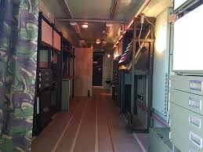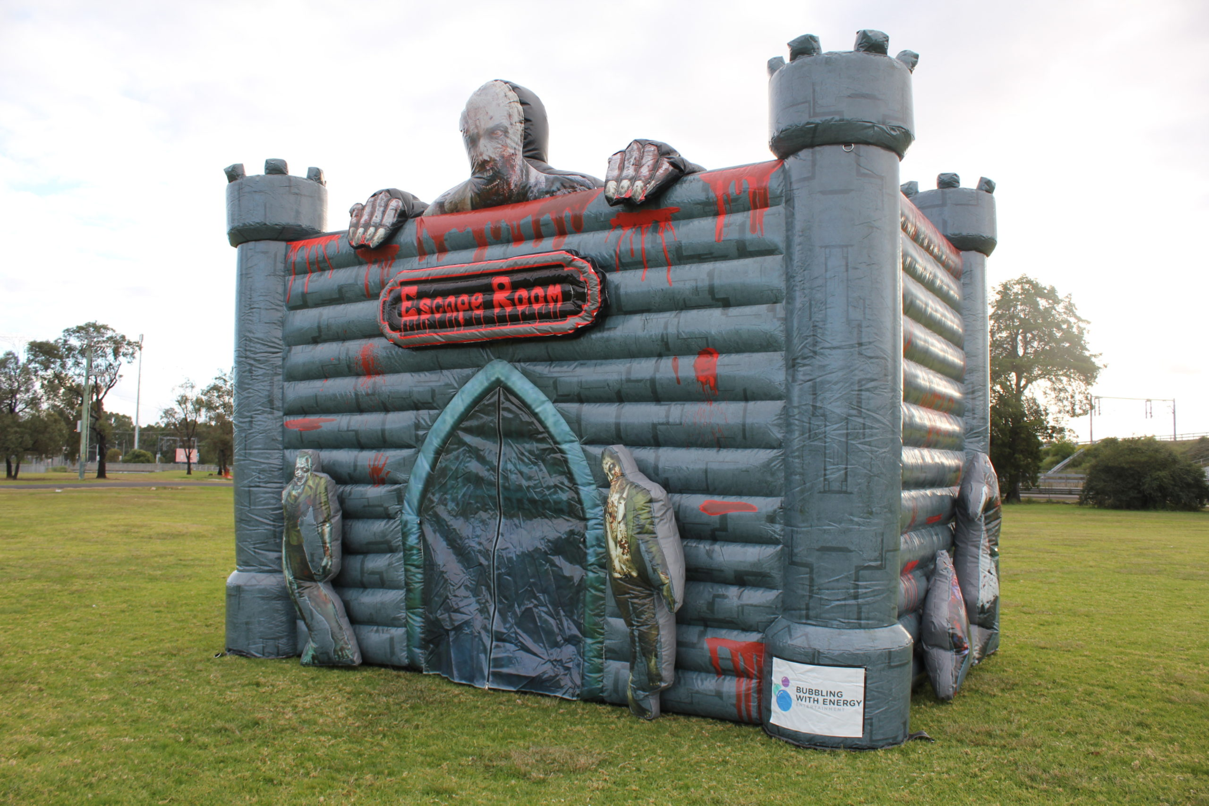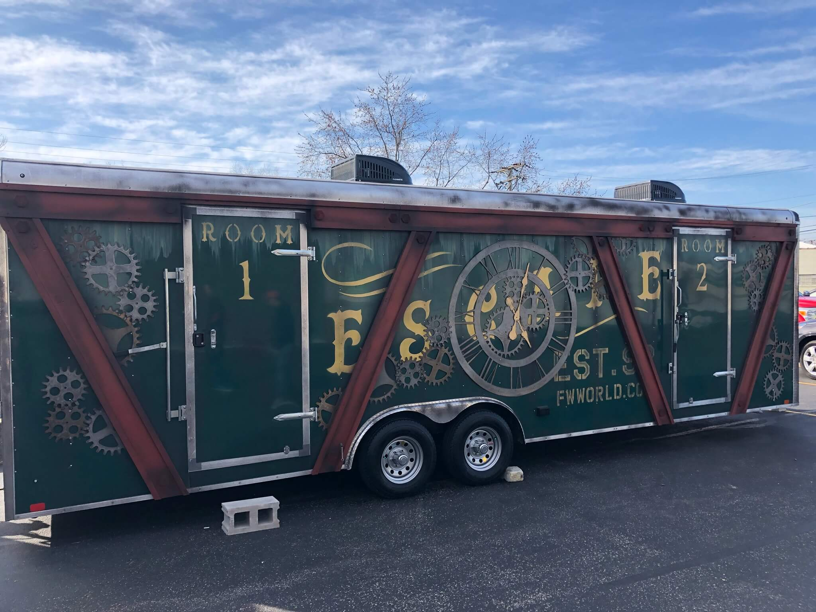

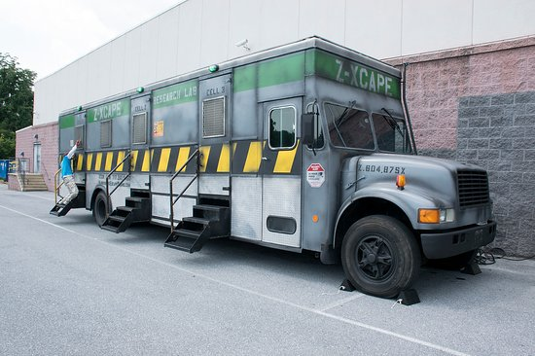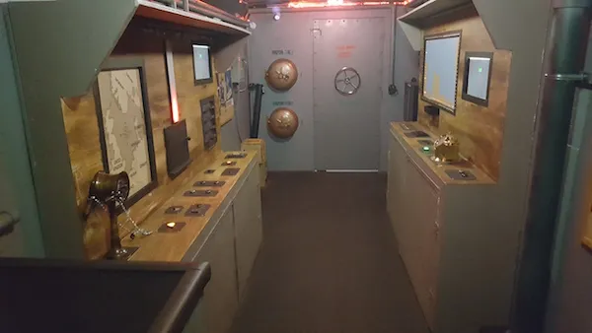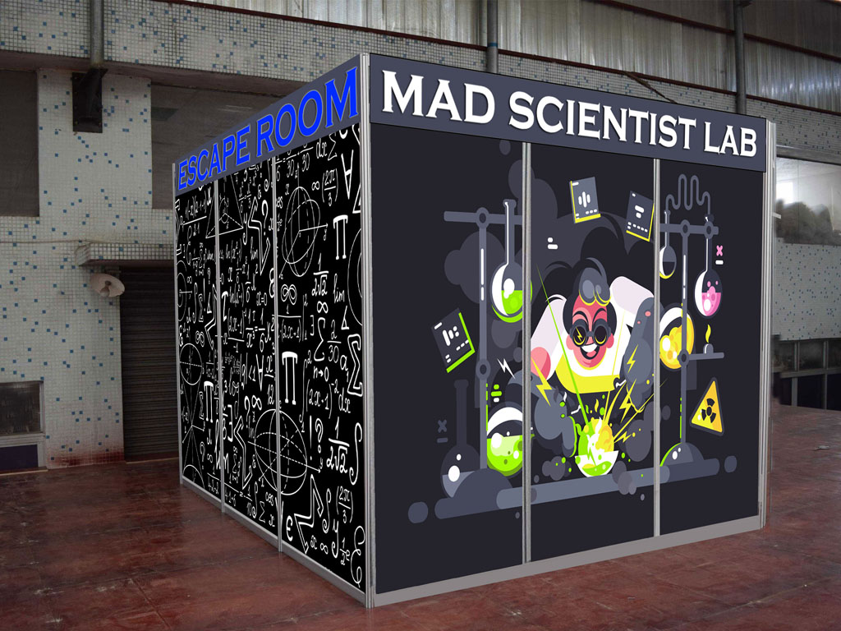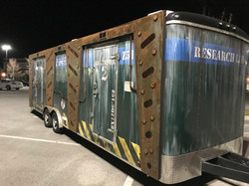

**Advice**

When building an escape room in either real life or online it is important to make use of a theme, this can be done with a story and lore but for the game we are creating I advise to just make use of themed rooms. Because the questions in the rooms can be themed towards anything from science to history to language. Using themed rooms makes it so a teacher can easily pick a setting for the room without having to deal with a story that needs to make sense.

**Sources**

* *Escape Room Themes*. (z.d.). Escape Room Player. Geraadpleegd op 7 maart 2022, van <https://escaperoomplayer.com/Escape_Room_Themes.html>
* *Google*. (z.d.). Google Images. Geraadpleegd op 7 maart 2022, van <https://www.google.com/?&bih=937&biw=1920&rlz=1C1VDKB_nlNL945NL945&hl=nl> *For images*
* Shapiro, C. (2021, 27 oktober). *Types of Escape Rooms | Comprehensive Guide*. The Escape Game. Geraadpleegd op 7 maart 2022, van <https://theescapegame.com/blog/types-of-escape-rooms/>
* *Youtube*. (z.d.). Youtube. Geraadpleegd op 7 maart 2022, van <https://www.youtube.com/> *Watching people play escape rooms*